1. Migrated APPRV MR

STILL CANNOT ISSUE MR00477685, MR00477945,   
DEM100845,   
DEM100820

MR00004322 (appr status – have reservation records).

SHOULD HAVE BEEN FIXED. TRY AGAIN.

1. Approve migrated MR with WAPPR Status. Can approve but cannot complete issue.

SHOULD HAVE BEEN FIXED. TRY AGAIN.

1. Migrated PO in EUR Currency

A44-DRS1-DOR1-0001XX

NEED EXCHANGE RATE AT THE POINT OF PO CREATION.

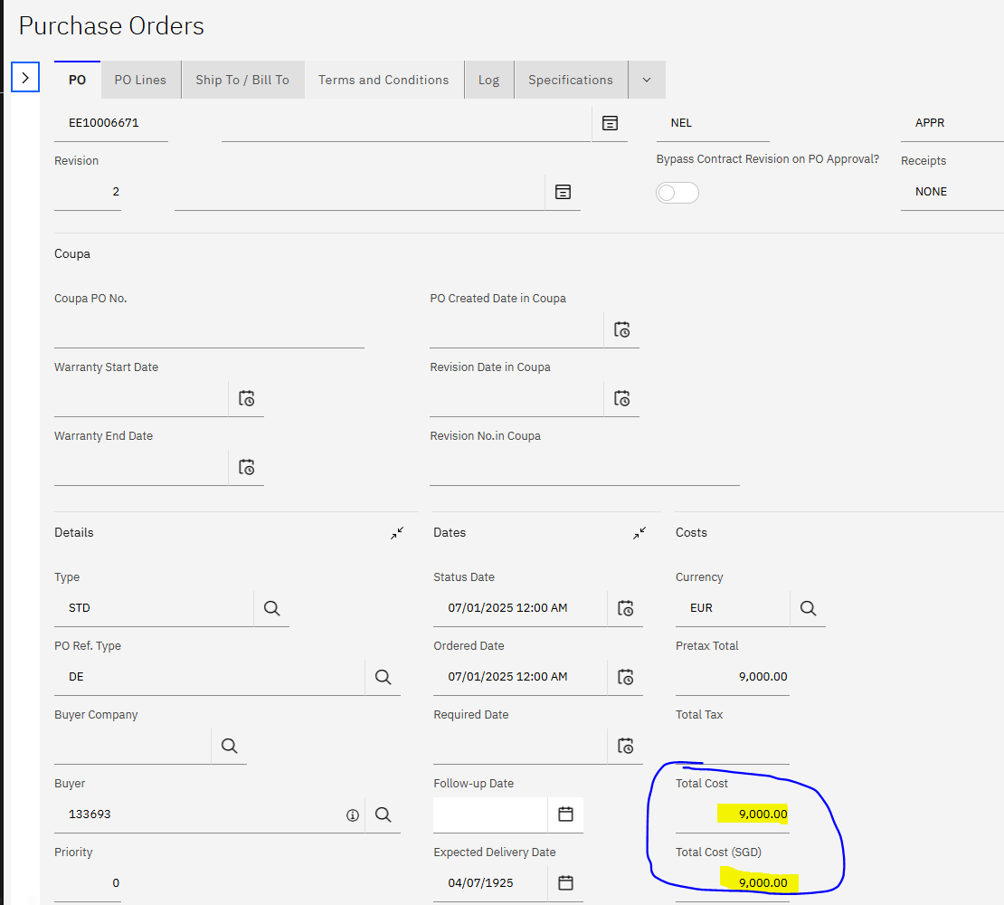

Newly created PO in EUR Currency:

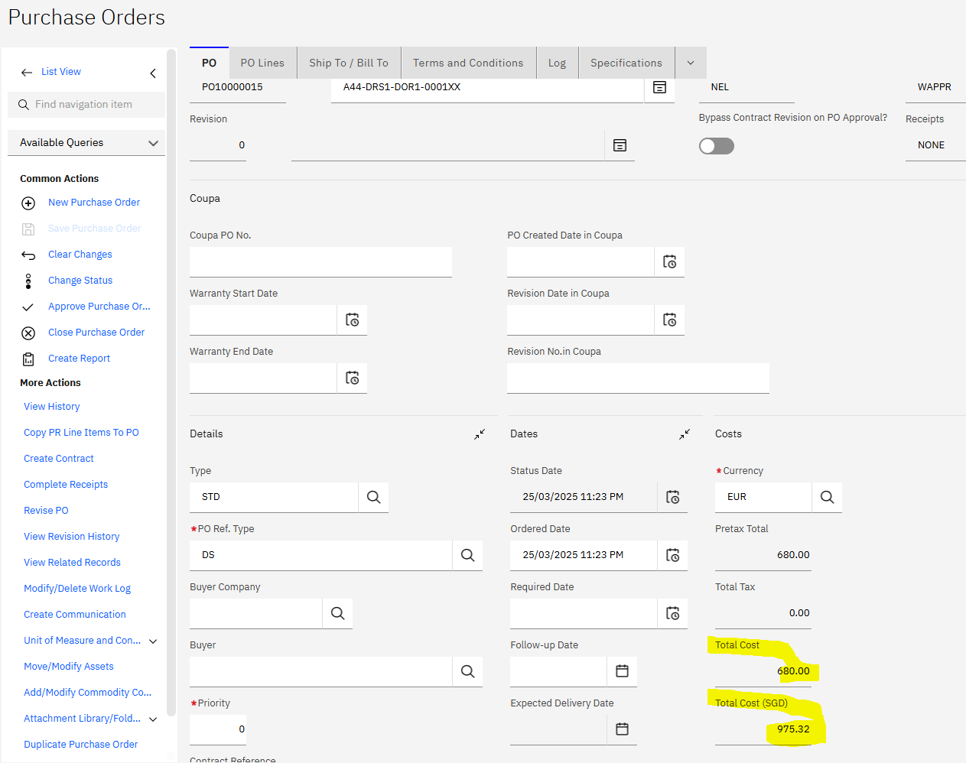

1. Is the Inspection to be enabled ? (migrated PO)

IT IS NOW ENABLED IN BOTH PO AND POLINE.

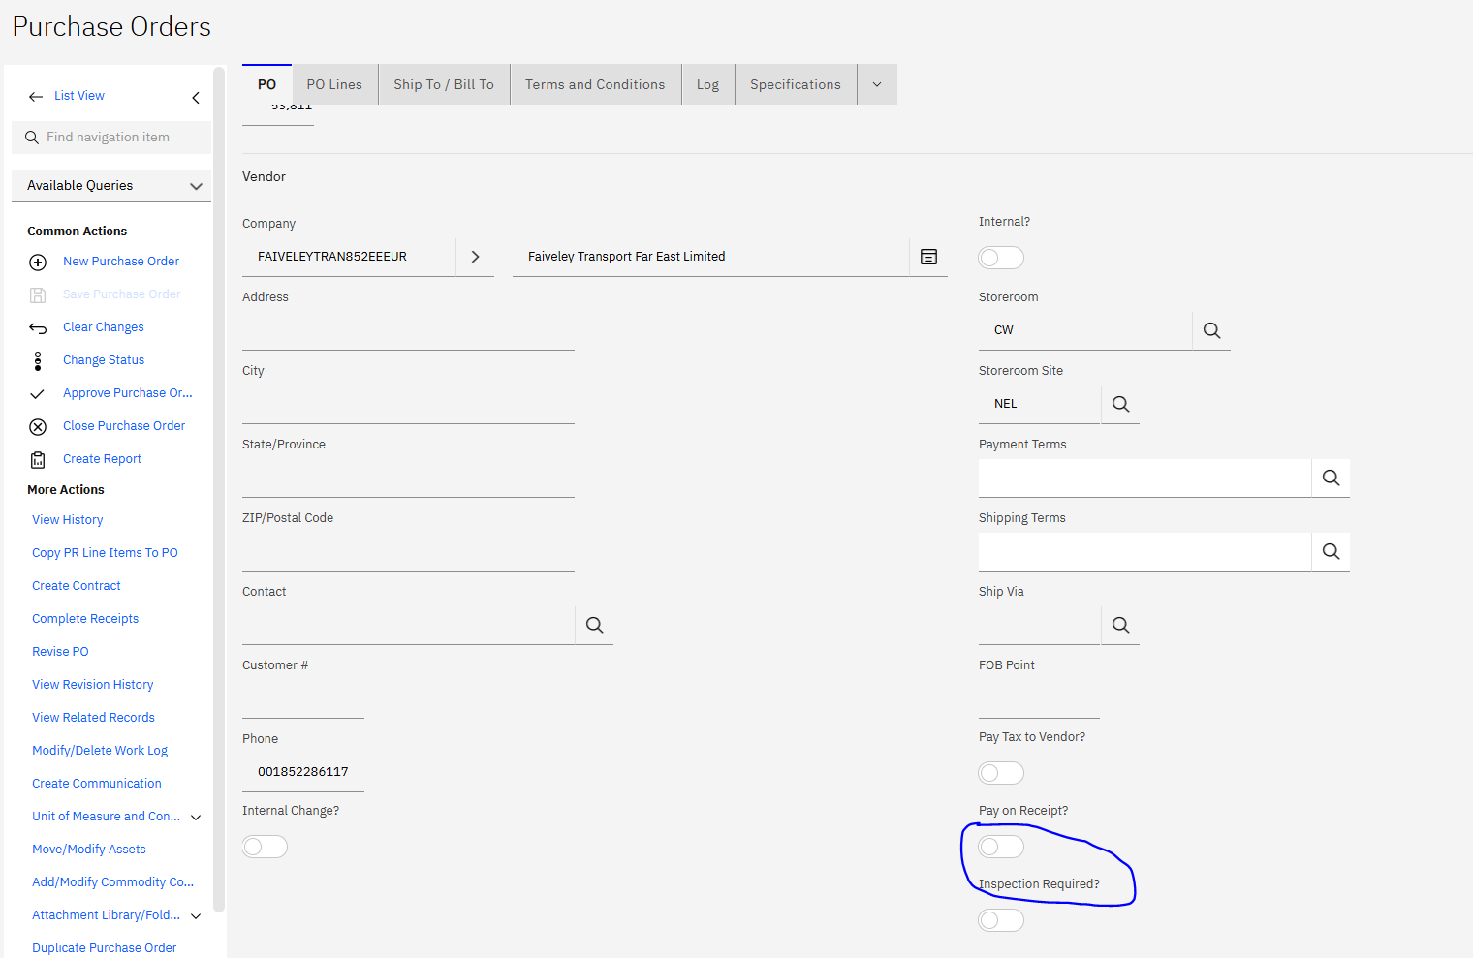

1. Create new PO

Can the Inspection required be click ? now cannot click.

SOFTWARE ISSUE

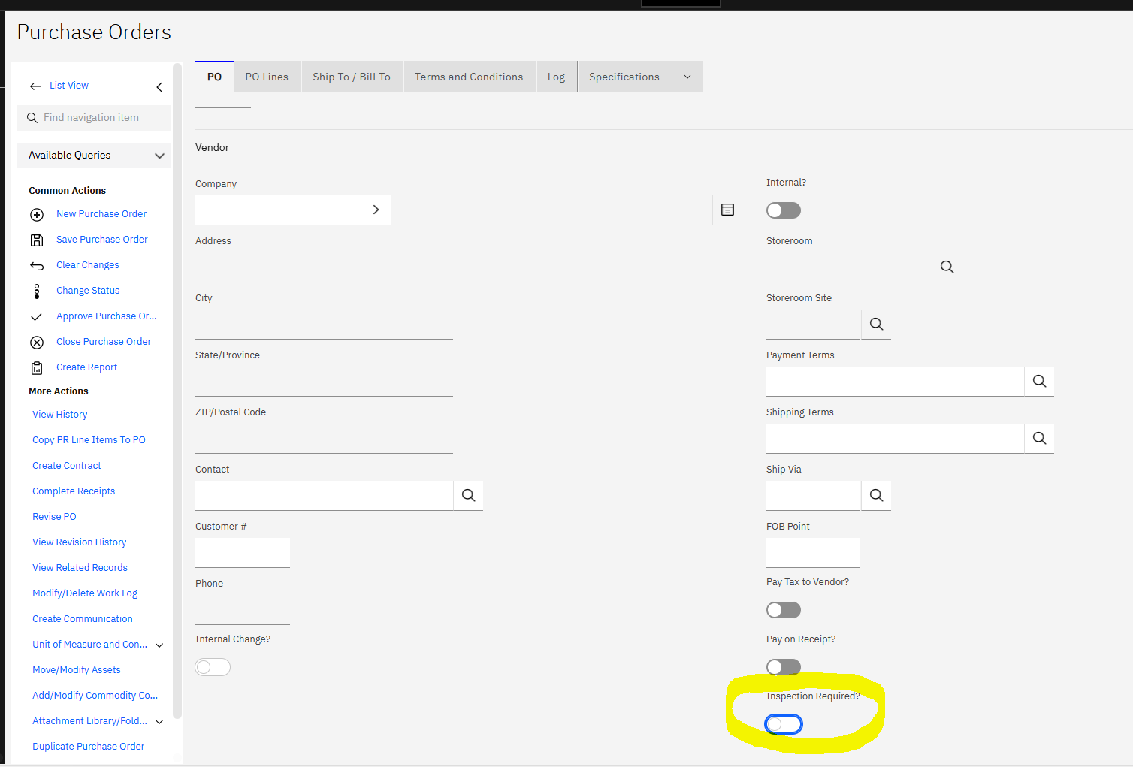

1. Migrated PO# AA10001616, Receipt complete, but data shown “none”

NOT SURE WHAT IE MEANS.

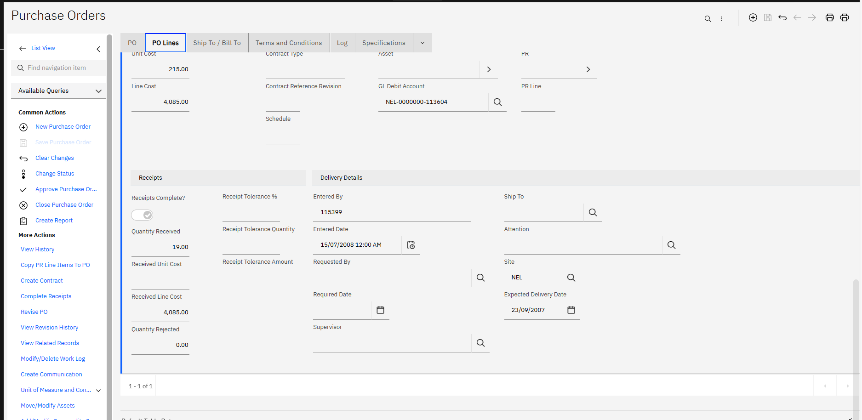

1. PO#AA10017116, PO Header, inspection required is ‘No”, PO Line Item “Yes”

Is this correct ?

IT IS NOW ENABLED IN BOTH PO AND POLINE.

1. Item with Coswin Item Entity, Status to update to “Inactive”

ITEM WITH COSWIN ENTITY = ‘TEMP’ IS NOW SET TO STATUS=PLANNING

1. To fill up for Line

WHERE TO GET THE LINE INFO? LOCATION?

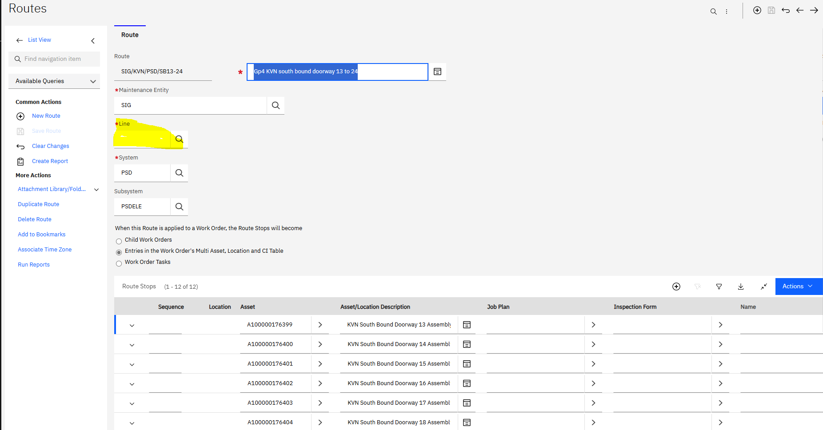

1. AA10017110
2. Full receipt for 2 line item.
3. PO# AA10017130
4. AA10017137 – FULL Inspection -ok.
5. AA10017066 – Reject 1, ok
6. AA10017128 – Reject 1, accept 1 - ok.
7. PO

Inspection Required --- cannot click ??

1. Khai Ming
2. To perform receipt.